Adafruit 128x64 OLED Bonnet for Raspberry Pi

**Adafruit 128x64 OLED Bonnet for Raspberry Pi**

PRODUCT ID: 3531

$22.50

<https://www.adafruit.com/product/3531>

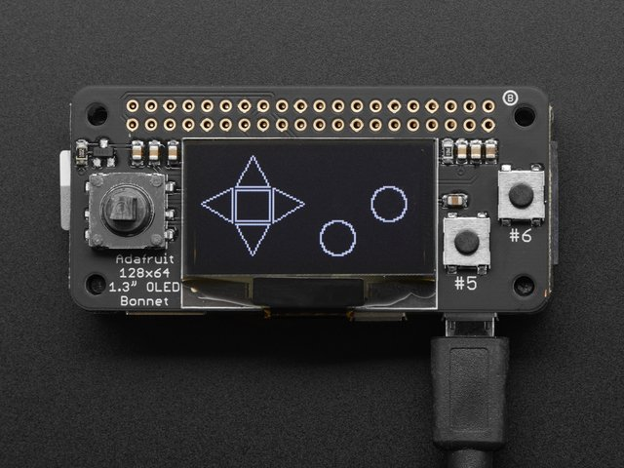

If you'd like a compact display, with buttons and a joystick - we've got what you're looking for. The Adafruit 128x64 OLED Bonnet for Raspberry Pi is [the big sister to our mini PiOLED add-on](https://www.adafruit.com/product/3527). This version has 128x64 pixels (instead of 128x32) and a much larger screen besides. With the OLED display in the center, we had some space on either side so we added a 5-way joystick and two pushbuttons. Great for when you want to have a control interface for your project.

[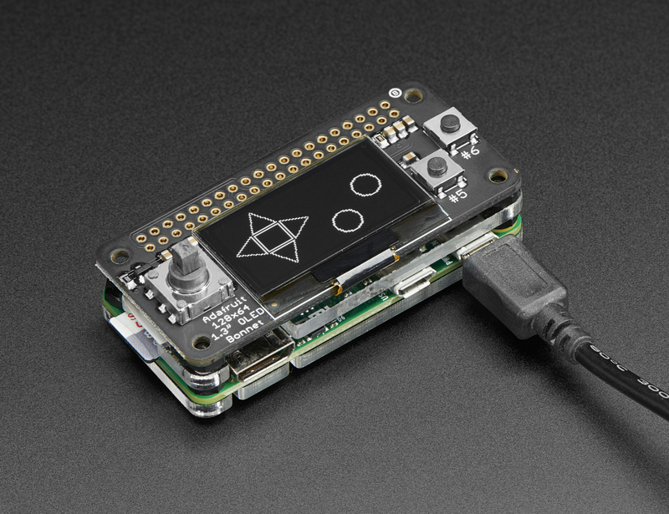](https://learn.adafruit.com/assets/42450)

These displays are small, only about 1.3" diagonal, but very readable due to the high contrast of an OLED display. This screen is made of 128x64 individual white OLED pixels and because the display makes its own light, no backlight is required. This reduces the power required to run the OLED and is why the display has such high contrast; we really like this miniature display for its crispness!

[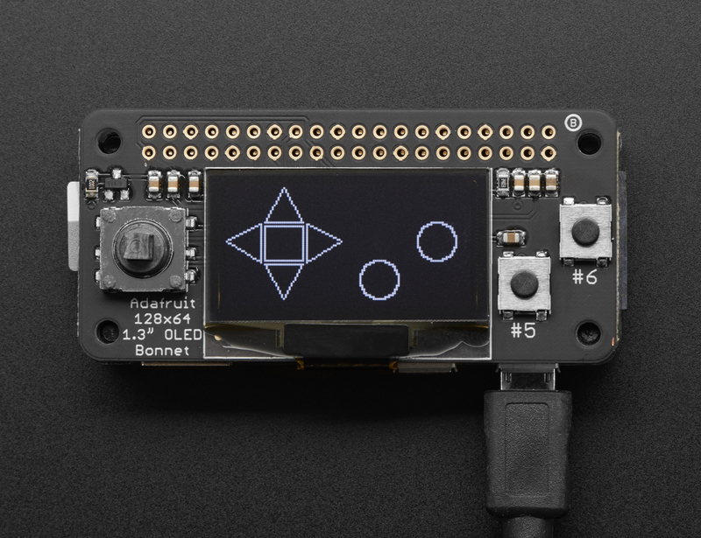](https://learn.adafruit.com/assets/42455)

**Please note that this display is too small to act as a primary display for the Pi** (e.g. it can't act like or display what would normally be on the HDMI screen). Instead, we recommend using **pygame** for drawing or writing text.

Using the display and controls in python is very easy, we have a library ready-to-go for the SSD1306 OLED chipset and the joystick/buttons are connected to GPIO pins on the Pi. Our example code allows you to draw images, text, whatever you like, using the Python imaging library. We also have example code for using the joystick/buttons/OLED together. Our tests showed 15 FPS update rates once you bump the I2C speed to 1MHz, so you can do animations or simple video.

[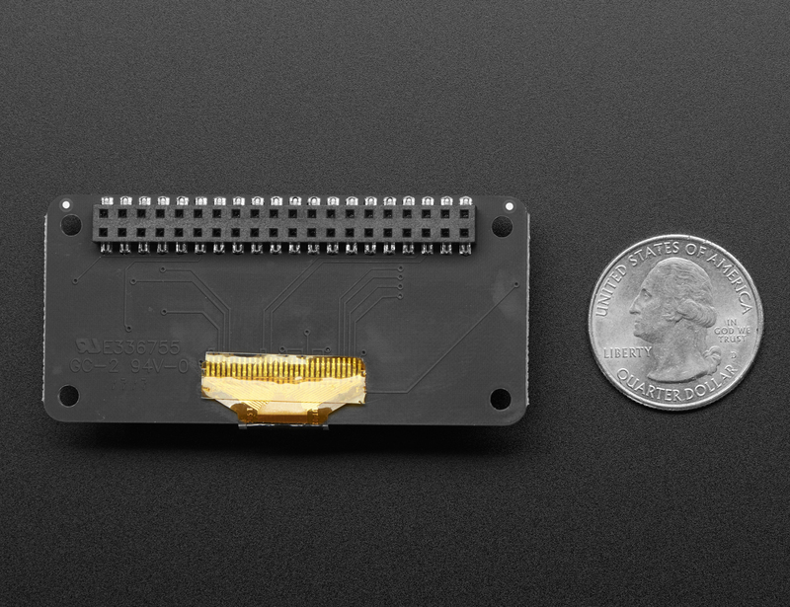](https://learn.adafruit.com/assets/42454)

**Comes completely pre-assembled and tested** so you don't need to do anything but plug it in and install our Python code! Works with any Raspberry Pi computer, including the original Pi 1, B+, Pi 2, Pi 3 and Pi Zero.

This guide was first published on Jun 09, 2017. It was last updated on Jun 09, 2017.

This page (Overview) was last updated on Apr 06, 2021.

Text editor powered by [tinymce](https://www.tiny.cloud/).